Members’ Name:

|  |  |  |
| --- | --- | --- |
| Student Name | Student ID | Email |
| Salma Shady Mohamad Talaat Hashem El-Etreby | 202005204 | Se2005204@qu.edu.qa |
| Aya Muhanad Mahmoud Hassan | 202003532 | ah2003532@qu.edu.qa |
| Hissa Al Muhannadi | 202001942 | ha2001942@qu.edu.qa |

Chosen ER diagram: University

Schema:

Legend:

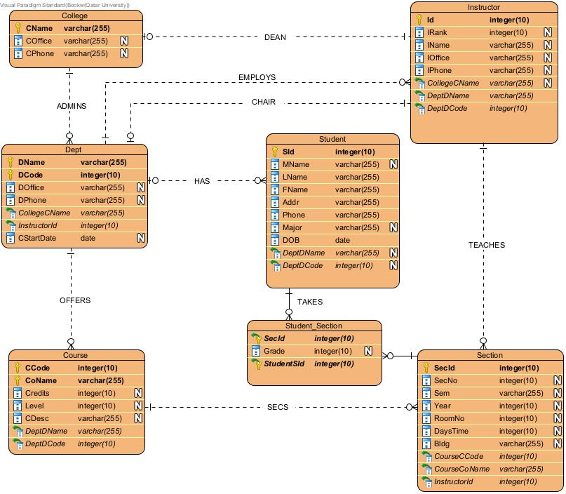

SQL Table:

SQL Commands:

CREATE TABLE College (

CName VARCHAR(255) PRIMARY KEY,

COffice VARCHAR(255) ,

CPhone VARCHAR(255)

)

CREATE TABLE Dept (

DName VARCHAR(255),

DCode Integer(10) ,

DOffice VARCHAR(255) ,

DPhone VARCHAR(255) ,

CStartDate date NOT NULL,

CollegeCName VARCHAR(255) NOT NULL ,

FOREIGN KEY (CollegeCName) REFERENCES College(CName),

PRIMARY KEY (DName, DCode)

)

CREATE TABLE Course (

CCode Integer,

CoName VARCHAR(255) ,

Credits Integer,

Level Integer,

CDesc VARCHAR(255),

DeptDName VARCHAR(255) NOT NULL,

DeptDCode integer NOT NULL,

FOREIGN KEY (DeptDName,DeptDCode) REFERENCES Dept(DName,DCode),

PRIMARY KEY (CCode, CoName)

)

CREATE TABLE Student (

SId Integer PRIMARY KEY,

MName VARCHAR(255) ,

FName VARCHAR(255) ,

LName VARCHAR(255) ,

Addr VARCHAR(255) ,

Phone VARCHAR(255) ,

Major VARCHAR(255) ,

DOB date,

DeptDName VARCHAR(255) ,

DeptDCode integer,

FOREIGN KEY (DeptDName,DeptDCode) REFERENCES Dept(DName,DCode)

)

CREATE TABLE Instructor (

Id Integer PRIMARY KEY,

IRank integer ,

IName VARCHAR(255) ,

IPhone VARCHAR(255) ,

IOfficee VARCHAR(255) ,

CollegeCname VARCHAR(255) ,

DeptDCode integer NOT NULL,

DeptDName VARCHAR(255) NOT NULL ,

FOREIGN KEY (DeptDName,DeptDCode) REFERENCES Dept(DName,DCode),

FOREIGN KEY (CollegeCname) REFERENCES College(CName)

)

CREATE TABLE Section (

SecId Integer PRIMARY KEY,

SecNo integer ,

Sem VARCHAR(255) ,

Year integer,

RoomNo integer,

DaysTime integer,

Bldg VARCHAR(255),

CourseCCode integer NOT NULL,

CourseCoName VARCHAR(255) NOT NULL,

InstructorId integer NOT NULL,

FOREIGN KEY (CourseCCode,CourseCoName) REFERENCES Course(CCode,CoName),

FOREIGN KEY (InstructorId) REFERENCES Instructor(Id)

)

CREATE TABLE Student_Section (

SecId Integer ,

Grade integer ,

StudentStd integer ,

primary key(SecId,StudentStd),

FOREIGN KEY (SecId) REFERENCES Section(SecId),

FOREIGN KEY (StudentStd) REFERENCES Student(SId)

)

Had to do alterations

secti

ALTER TABLE Dept

ADD COLUMN InstructorId integer;

ALTER TABLE Dept

ADD CONSTRAINT

FOREIGN KEY (InstructorId)

REFERENCES Instructor (Id);

SQL tables: